**MAHENDRA INSTITUTE OF TECHNOLOGY**

|  |  |  |  |  |  |  |  |  |  |  |  |  |  |
| --- | --- | --- | --- | --- | --- | --- | --- | --- | --- | --- | --- | --- | --- |
|  | **Department of Computer Science and Engineering**  **Smart Farmer-IOT Enabled Smart Farming Application**  **IBM NALAIYATHIRAN**     |  |  | | --- | --- | | **TITLE** | **Smart Farmer-IOT Enabled Smart Farming Application** | | **DOMAIN NAME** | INTERNET OF THINGS | | **TEAM ID** | PNT2022TMID17252 | | **LEADER NAME** | KARTHICKRAJA M | | **TEAM MEMBER NAME** | KAVIN M  KAVIYARASAN R  LOGANATHAN K | | **MENTOR NAME** | DIVYA BHARATHI G | |

**ASSIGNMENT 2**

**PROGRAM:**

import random

while(True):

a=random.randint(10,100)

b=random.randint(10,100)

if(a>35 and b>60):

print("High Temperature and Humidity of:",a,b,"%","Alarm is ON")

elif(a<35 and b<60):

print("High Temperature and Humidity of:",a,b,"%","Alarm is OFF")

break

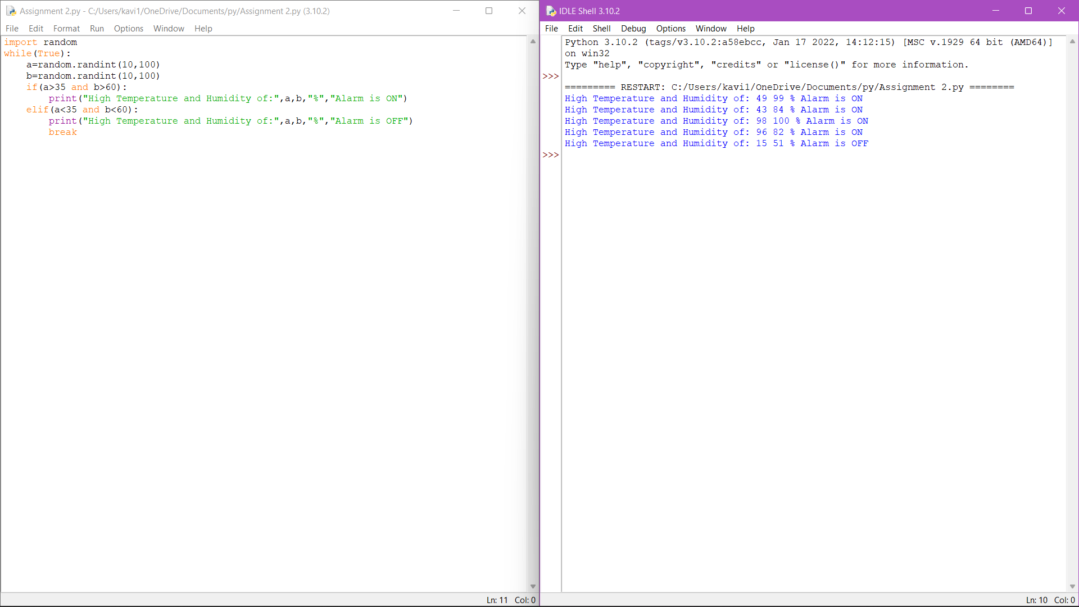

**Output:**